Instruction Template for Setting up Student LMS Integrated LabSim Accounts
Note to instructor: Within this template you will see multiple references to LMS (Learning Management System). As appropriate you might replace this with a more familiar name to your students, such as Blackboard, Canvas, Moodle, Brightspace, etc.
Introduction
To participate in this class you will need a one-time subscription to TestOut's online, simulation-based training product named TestOut <Name> Pro, a training resource produced by TestOut Corporation. The following steps will get you access and set you up to use the product:
Step 1: Purchase TestOut’s <Name> Pro product
- <Name> Pro is what we’re using, in the <Name> class at <School Name>. Your subscription remains active for 18 months; be sure to take your class while it’s active.
Option 1: Purchase from the School Bookstore
- Follow this link to find this product at the Bookstore. If you are on financial aid, you may need to choose this option.
Option 2: Purchase from www.testout.com
- Have your credit or debit card ready and go to www.testout.com.
- Look to the lower-right quadrant for the “Need to buy a LabSim course?” area. 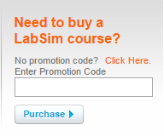
- Within the Enter Promotion Code field enter promo code <code> to get student pricing.
- Our ISBN is <ISBN>.
Either of the above two purchase options result in you receiving a product activation code. If purchased from www.testout.com, activation codes will arrive to you via email (be sure to check your spam folder if you don’t see the code in your Inbox).
Step 2: Creating the LabSim Account
- From your LMS student account click the link for <assignment name>.
- If prompted, enter your LabSim product activation code, then click the “Activate” button to proceed into your first assignment. Entering an activation code is a one-time incidence. A LabSim account is automatically created for you in the background. 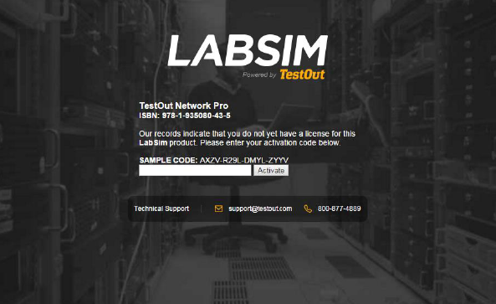
Step 3: Verify that you can see assignments
- Click the <Name> assignment link. This should launch the product title and take you to the assignment within the product title.
- After you are satisfied that you have linked to the assignment / learning resource, stop and proceed to Step 4 below.
Step 4: Completing Assignments and Submitting Scores to the LMS
- There are direct links to each LabSim assignment inside the LMS course. For scores to be returned from LabSim to the LMS each respective LabSim assignment must be accessed from the LMS course.
- If you do not follow LMS links to each of your assignments, your scores cannot be submitted to the LMS gradebook. You must return to the LMS after you complete each LabSim assignment and link to the next assignment.
  - Submitting scores to the LMS via the “Submit Scores” button:
To see the “Submit Score” button within LabSim you need to link to each assignment from the LMS course. You will then see the “Submit Score” button on the title bar of the assignment. 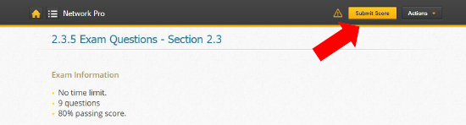
Caution: Navigating within LabSim, from say resource 4.3.5 to 4.7.8, when you have specifically linked to 4.3.5, would result in a Submit Score button being unavailable for 4.7.8. But when you return to the LMS course and directly link to 4.7.8 you will see the “Submit Score” button.
If the student attempts to navigate away from a score-able assignment before submitting their score a warning dialog is generated which advises the student to submit their score:
